REF: PLE/RRN/CC

Thursday 21st March 2024

Re: Class Charts - Detentions

Dear Parent/Carer,

When booking in detentions for your child/children that are longer than 15 minutes, we have always communicated this through a telephone conversation with parents/carers. However, we are now finding that our staff are not getting through to many parents/carers and are having to leave numerous voicemail messages. As a result of this, Retests, Stage 3, Stage 4 and Head of School detentions are not being booked in and this has led to a large backlog of detentions that are not being sat by students.

As a result, from Monday 8th April 2024, we will provide two channels of communication when staff book in any detentions that are longer than 15 minutes (multiple retests, Stage 3, Stage 4 and Head of School detentions). The first will be via a telephone call to yourselves. If there is no answer, a voicemail shall be left on your respective number. Staff will then put the detention on Class Charts with details regarding why it was set and an appropriate date for it. If there are any issues with the date of the detention, it will be your responsibility to contact us to rearrange if required.

We assume that you will have the Class Charts app downloaded on your mobile phone. If you do not, please contact the Academy where we will be able to provide you with any relevant logins for your child/children.

If you require any assistance or have any further queries, please contact the Academy where your child’s PLD or Mr. Rahman will be happy to speak with you.

Yours Faithfully,

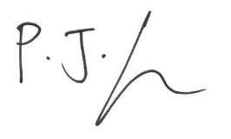

Mr. P. Lee
Headteacher

